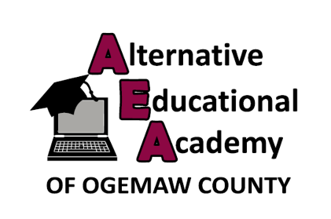
Alternative Educational Academy of Ogemaw County
2479 South M-76
West Branch, MI 48661
(989) 343-9070

March 11, 2021

Dear School Community,

As noted on our COVID-19 Dashboard at ogemawaea.net, on March 11, 2021, we learned about at least one School Associated Case of COVID-19 in a student or staff person at the Alternative Educational Academy of Ogemaw County-West Branch Learning Lab. Cleaning and disinfecting of the exposed location(s) has been completed.

The Alternative Educational Academy-West Branch Learning Lab will be closed until March 22, 2021. We are working closely with the District Health Department #2 to identify Close Contacts of School Associated Cases of COVID-19. Anyone identified as a Close Contact will be notified by the health department as a part of the COVID-19 investigation process. Please answer the phone if the health department contacts you, as a contact tracer may be trying to reach you with important information.

We recommend taking action to help limit the spread of COVID-19, even if staff members or students are not experiencing symptoms:
- Wear a mask (covering mouth and nose) while in public places or if people who do not live with you must visit your home.
- Practice social distancing (maintaining a distance of 6 feet apart).
- Practice frequent handwashing (using soap for 20 seconds or hand sanitizer with 60% alcohol).
- Follow capacity restrictions of social gatherings.
- Cover coughs and sneezes with a tissue or with the inside of your elbow and immediately wash your hands.
- Stay home if you are sick; you can also get tested.

Thank you for understanding that, due to medical privacy laws, we are not able to release the names of the individuals with COVID-19. We will continue to communicate changes and updates with you. With your participation, we believe we can maintain a safe environment while also providing quality education.

If you have any questions, contact District Health Department #2 at
989-345-5020. For answers to your COVID-19 questions, please call the Michigan Department of Health and Human Services COVID-19 Hotline at 888-535-6136 or visit Michigan.gov/coronavirus.

Sincerely,

Tina Williams
Alternative Educational Academy Director

